Outline Solutions for Chapter 1

Mini-case 1.1: Inventory Planning
Purpose | Develop an overall system that would generate automatic information on ordering, leaving management to “manage by exception” and consider only these items that do not seem to be operating in accordance with historical patterns.  How long will current stocks need to last? We know the lead-times (time to delivery on an order placed today) are 2-4 weeks, so the forecast horizon need to extend to cover the lead-times.
Information | We may assume that records of sales for each SKU are available on a weekly basis (would daily help in this case?). Forecasts from the current inventory system would typically use a stock level that included a safety stock over and above the predicted level of sales over the lead-time. Information on the current software and the expertise of the staff is also needed.
Analysis | The first step must be to establish how the company forecasts, whether it is an automatic method or whether managerial judgments are used. The products need to be analyzed by value.). However, the inventory consists of a large number of small value components so highly detailed forecasting for individual components is not warranted. We would probably use extrapolative (single series) methods and develop a framework based upon a sample of series. Items that are more valuable and/or exhibit volatile patterns of demand would be sampled more heavily and may merit more detailed analysis including checking whether management knowledge improves accuracy. (Discussed further in chapters 11 and 12).
Value | The value of the overall system could be very high (e.g. Walmart’s supply chain management system Small improvements when there are many products can generate large financial benefits.
System | The focus of the case is to design an efficient and accurate a forecasting system. With a large number of products the system needs to be primarily automatic. Management would focus on those products that showed unusual patterns.
Evaluation | Record actual and forecast sales and then examine stock-outs and excess inventory. Check any managerial adjustments.

Minicase 1.2: Long-term Growth
Purpose | The consultancy needs to show how it can deliver a model/ methodology that can provide a flexible framework for the assessment of the company growth that allows for different “what-if” possibilities, such as changes in demand for the medical equipment or new uses for the chip.  The management will be interested in the company’s longer-term prospects over the next 5 and possibly up to 10 years.
Information | Interest will focus upon broad areas of operation. Data on the past market for existing uses, including competitors, in particular with regard to the products that currently use a less sophisticated chip. On the technological side, you would need to evaluate the possibilities of further breakthroughs that might reduce the current market. This would require identification of relevant patents.
Value | The value will be very high if the company uses the resulting forecasts to plan for the years ahead. Hence a “what-if” component is critical to the forecasts; single numbers will be of marginal value.
Analysis | Forecasts for the new markets would prove particularly important. Both the market size by segment, the company’s share and also the timing of the uptake are needed. Finally, aspects of economic activity in those medical specialties sectors where the chip is most likely to be used would be needed. such information could be obtained from an external econometric forecasting model and/or “what-if” considerations.
System | The case is unclear as to whether what is needed is a financial model that includes key demand parameters for the different specialty products or whether the company would just want a one-off report.
Evaluation | Provided the company is not a start-up, the model may be tested against its historical performance. If the company is very new, it may be necessary to look more broadly at trends in the electronics industry. One problem with this approach is “survival bias” as only the successful companies are still around.

Minicase 1.3: Sales Forecasting
Purpose | The company needs to forecast both potential sales and the likely split of orders among payment plans in order to operate both its inventory system and to monitor cash flow.  Many clothing items are fashion-driven: that is, they will sell for only one season. Also, the company’s cash flow is dependent upon past sales revenues and on future sales with a short payment period. Planning is likely to focus on developments over the next twelve months
Information | Information on past sales by product type, channel (internet,  The company will be able forecast revenues from past sales fairly accurately, with due allowance for defaults. Past sales data may be used to forecast items with long-term appeal, but forecasting fashion goods will depend upon the use of analogies: past sales in that category of apparel. The relative levels of purchasing under each plan would be available, ideally broken down by broad product class. Cash flows for each product can be forecast and monitored so that the company is aware of its sources of net revenue and of potential shortfall.
Value | The value will be very high provided the company has an integrated management system so that the forecasts are updated regularly potential problems dealt with in timely fashion.
Analysis
System
Evaluation | Provided the company is not a start-up, the system may be tested against its historical performance. If the company is very new, it may be necessary to build a model of similar companies in the industry and evaluate the model against their performance. One problem with this approach is “survival bias” as only the successful companies are still around.

Minicase 1.4: Adjusting for Inflation

Figure 1.2 (Real)
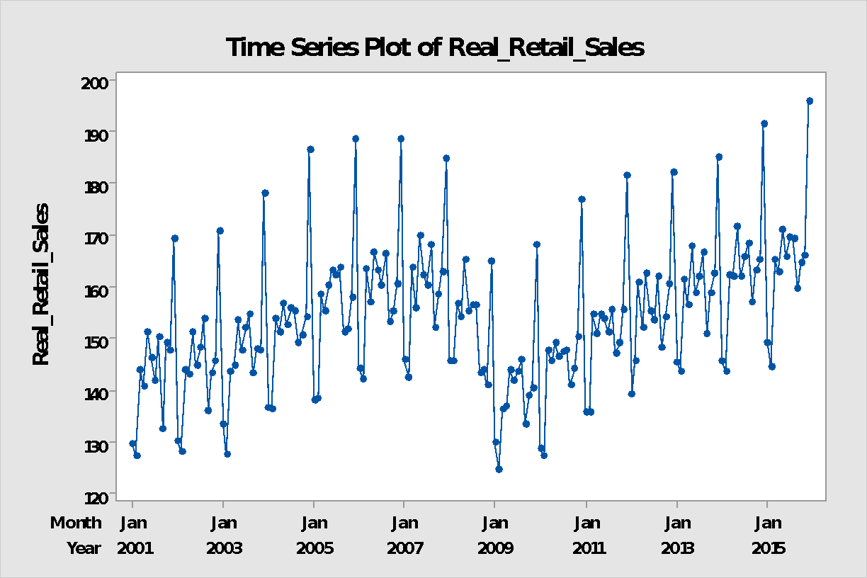

Figure 1.5 Month-on-Month % changes in U.S. Monthly Real Retailers Sales
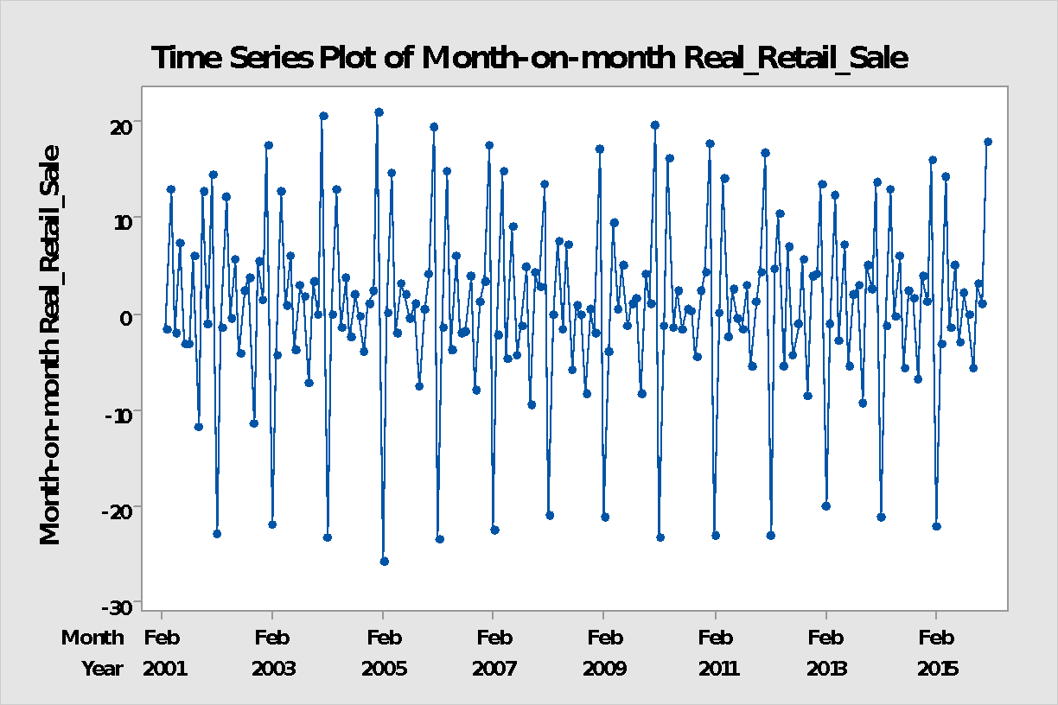

Figure 1.6) Year-Over-Year Percentage Change in U.S. Real Monthly Retailers Sales

